

CSA0506-Database Management Systems

CO2 AT-4

Debugging & Optimisation Task (Low)

Ashmi P S
192571004

1. Identify and Fix the Error in SQL JOIN Syntax
SQL CODE
Step 1: Create Database
CREATE DATABASE join_demo;
USE join_demo;
Step 2: Create Tables
CREATE TABLE Department (
dept_id INT PRIMARY KEY,
dept_name VARCHAR(50)
);

CREATE TABLE Employee (
emp_id INT PRIMARY KEY,
emp_name VARCHAR(50),
dept_id INT,
FOREIGN KEY (dept_id) REFERENCES Department(dept_id)
);
Step 3: Insert Records
INSERT INTO Department VALUES
(1,'HR'),
(2,'IT'),
(3,'Sales');

INSERT INTO Employee VALUES
(101,'John',1),
(102,'Alice',2),
(103,'David',2),
(104,'Sara',3);
Incorrect Query
SELECT emp_name, dept_name
FROM Employee, Department;

OUTPUT (Incorrect Query)
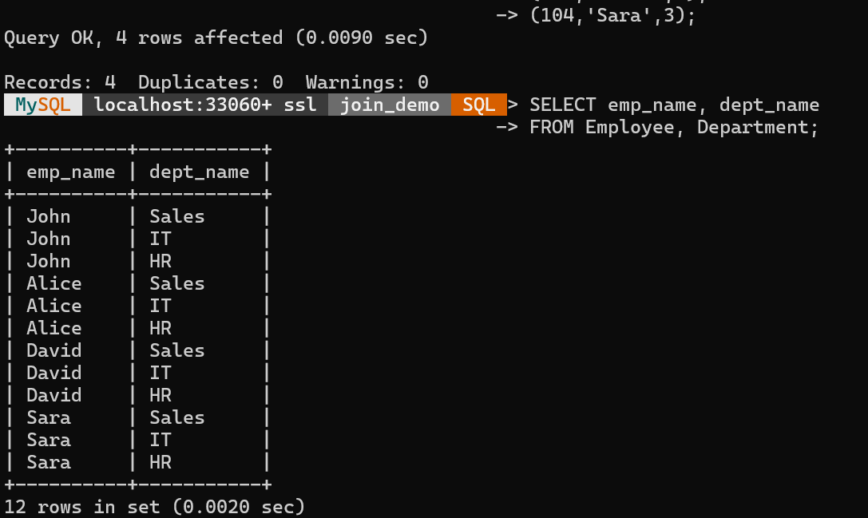

Correct Query
SELECT e.emp_name, d.dept_name
FROM Employee e
INNER JOIN Department d
ON e.dept_id = d.dept_id;

OUTPUT (Correct Query)
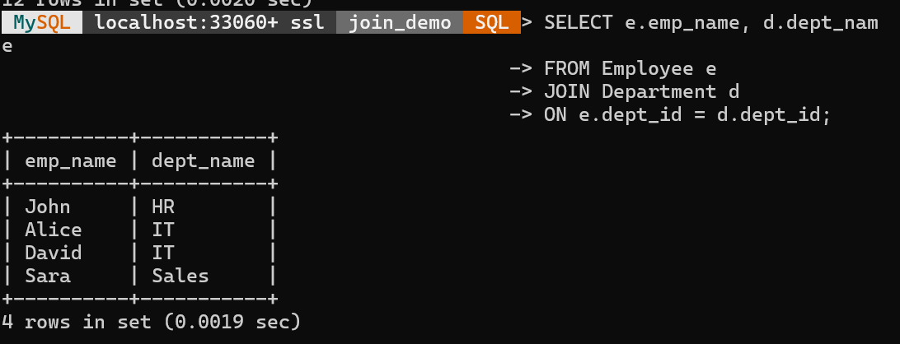

2. Identify and Fix Errors in a Correlated SQL Subquery
Step 1: Create Database
CREATE DATABASE subquery_demo;
USE subquery_demo;
Step 2: Create Table
CREATE TABLE Employee(
emp_id INT PRIMARY KEY,
emp_name VARCHAR(50),
dept VARCHAR(30),
salary INT
);

Step 3: Insert Records
INSERT INTO Employee VALUES
(101,'John','HR',40000),
(102,'Alice','IT',60000),
(103,'David','IT',70000),
(104,'Sara','HR',50000),
(105,'Kevin','Sales',45000),
(106,'Riya','Sales',55000);
Step 4: Incorrect Query (Missing Correlation)
SELECT emp_name, dept, salary
FROM Employee e
WHERE salary >
(
SELECT AVG(salary)
FROM Employee
);
Output (Incorrect)
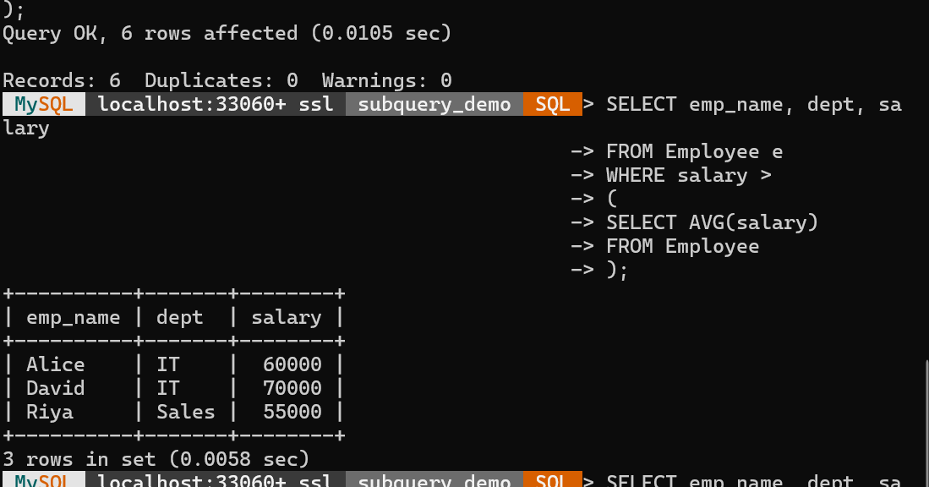
Step 5: Correct Query (Correlated Subquery)
SELECT emp_name, dept, salary
FROM Employee e
WHERE salary >
(
SELECT AVG(salary)
FROM Employee
WHERE dept = e.dept
);

Output (Correct)

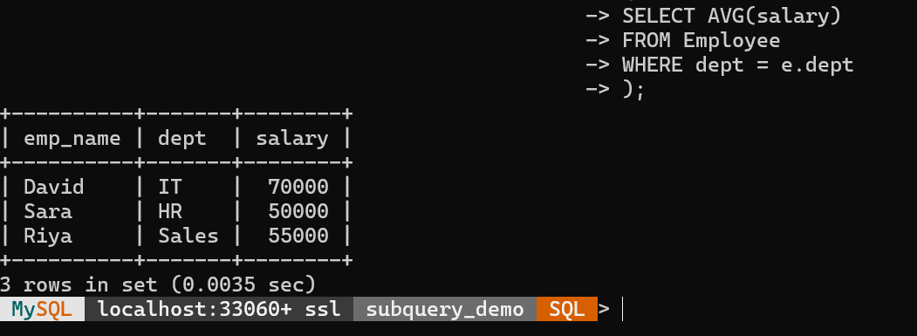

3.Creating and Debugging SQL Views
Step 1: Create Database
CREATE DATABASE view_demo;
USE view_demo;
Step 2: Create Table
CREATE TABLE Employee (
emp_id INT PRIMARY KEY,
emp_name VARCHAR(50),
department VARCHAR(30),
salary INT
);
Step 3: Insert Records
INSERT INTO Employee VALUES
(101,'John','HR',40000),
(102,'Alice','IT',60000),
(103,'David','IT',70000),
(104,'Sara','HR',50000);
Step 4: Incorrect View (Produces Error)
CREATE VIEW Employee_View AS
SELECT emp_name, dept, salary
FROM Employee;
Error
ERROR 1054 (42S22): Unknown column 'dept' in 'field list'
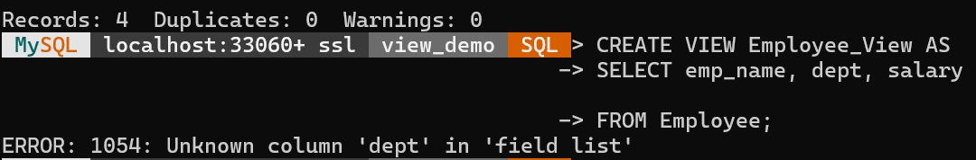
Step 5: Correct View
CREATE VIEW Employee_View AS
SELECT emp_id, emp_name, department, salary
FROM Employee;
Output:
Query OK, 0 rows affected
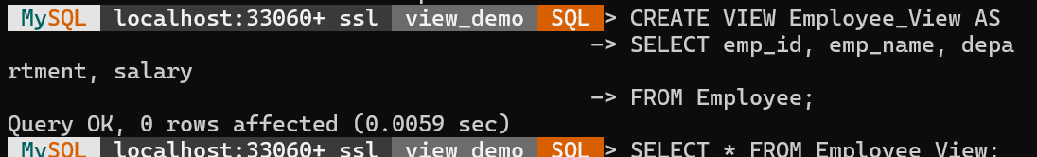
Step 6: Display the View
SELECT * FROM Employee_View;

OUTPUT
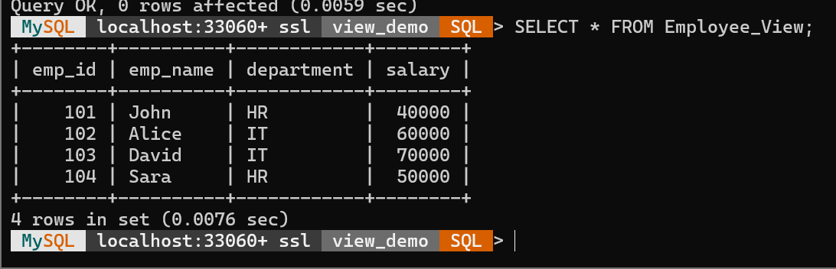

4.Debugging a Relational Algebra Expression for Natural Join
Step 1: Create Database
CREATE DATABASE natural_join_demo;
USE natural_join_demo;
Step 2: Create Tables
CREATE TABLE Department(
dept_id INT PRIMARY KEY,
dept_name VARCHAR(30)
);

CREATE TABLE Employee(
emp_id INT PRIMARY KEY,
emp_name VARCHAR(50),
dept_id INT,
FOREIGN KEY(dept_id) REFERENCES Department(dept_id)
);
Step 3: Insert Records
INSERT INTO Department VALUES
(1,'HR'),
(2,'IT'),
(3,'Sales');

INSERT INTO Employee VALUES
(101,'John',1),
(102,'Alice',2),
(103,'David',2),
(104,'Sara',3);
Step 4: Incorrect Query (Cartesian Product)
SELECT *
FROM Employee, Department;
Output (Incorrect)
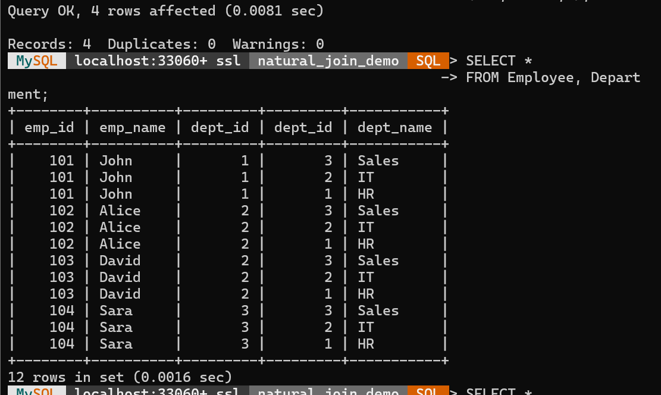

Step 5: Correct Query (Natural Join)
SELECT *
FROM Employee
NATURAL JOIN Department;

Output (Correct)
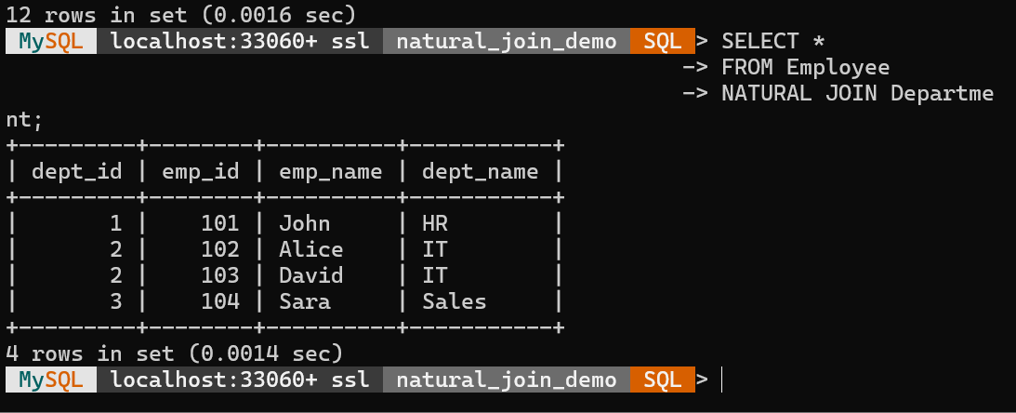

5.Enforcing Referential Integrity Using Foreign Key Constraints
Step 1: Create Database
CREATE DATABASE referential_demo;
USE referential_demo;
Step 2: Create Parent Table
CREATE TABLE Department(
dept_id INT PRIMARY KEY,
dept_name VARCHAR(30)
);
Step 3: Create Child Table
CREATE TABLE Employee(
emp_id INT PRIMARY KEY,
emp_name VARCHAR(50),
dept_id INT,
FOREIGN KEY (dept_id) REFERENCES Department(dept_id)
);
Step 4: Incorrect Query (Violates Referential Integrity)
INSERT INTO Employee VALUES
(101,'John',5);
Output (Incorrect)
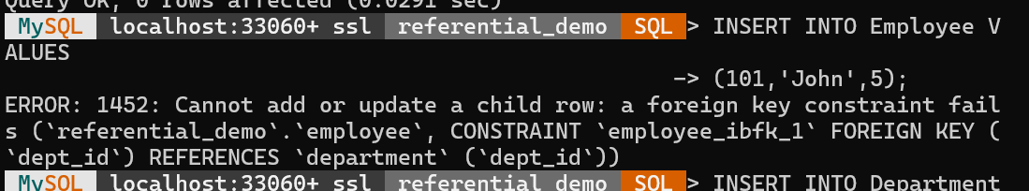
Step 5: Correct Query
Insert the Parent Record First
INSERT INTO Department VALUES
(5,'Finance');
Insert the Child Record
INSERT INTO Employee VALUES
(101,'John',5);
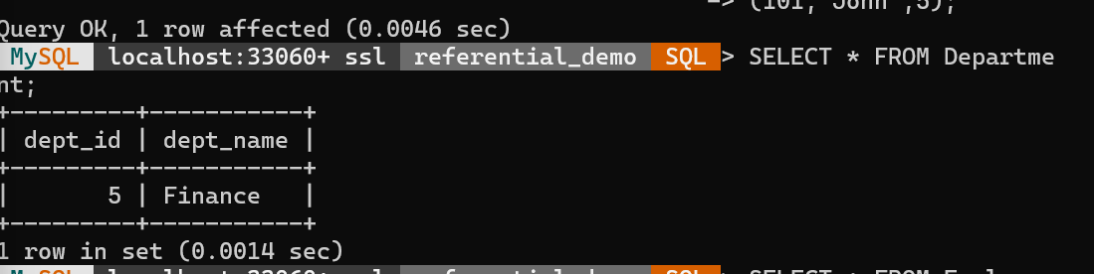
Step 6: Display the Records
SELECT * FROM Department;

Output
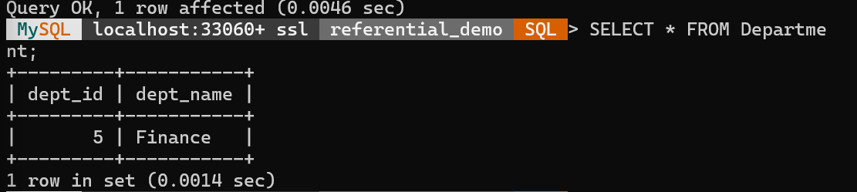
SELECT * FROM Employee;
Output
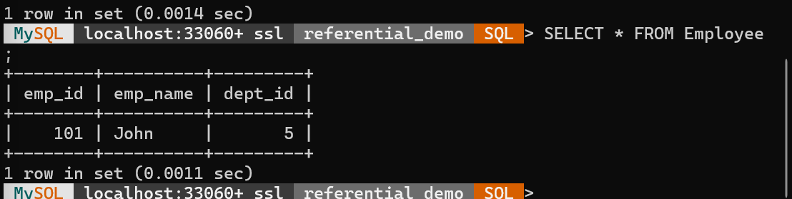

6.Optimizing an SQL Query by Replacing Nested Subqueries with JOIN
Step 1: Create Database
CREATE DATABASE join_opt_demo;
USE join_opt_demo;
Step 2: Create Tables
CREATE TABLE Department(
dept_id INT PRIMARY KEY,
dept_name VARCHAR(30)
);

CREATE TABLE Employee(
emp_id INT PRIMARY KEY,
emp_name VARCHAR(50),
dept_id INT,
FOREIGN KEY(dept_id) REFERENCES Department(dept_id)
);
Step 3: Insert Records
INSERT INTO Department VALUES
(1,'HR'),
(2,'IT'),
(3,'Sales');

INSERT INTO Employee VALUES
(101,'John',1),
(102,'Alice',2),
(103,'David',2),
(104,'Sara',3);
Step 4: Inefficient Query (Nested Subquery)
SELECT emp_name,
(
SELECT dept_name
FROM Department
WHERE Department.dept_id = Employee.dept_id
) AS Department
FROM Employee;
Output
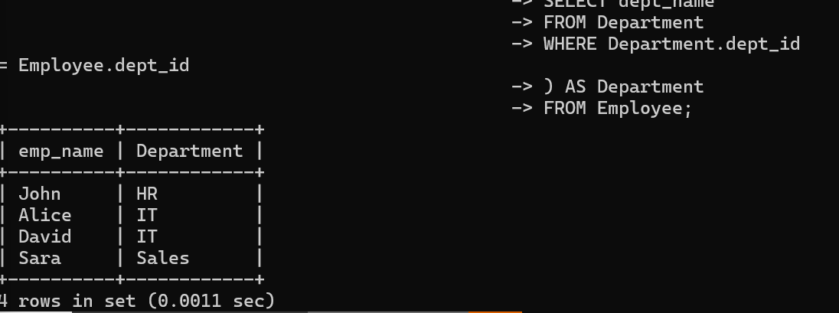
Step 5: Optimized Query (Using JOIN)
SELECT e.emp_name, d.dept_name
FROM Employee e
INNER JOIN Department d
ON e.dept_id = d.dept_id;
Output
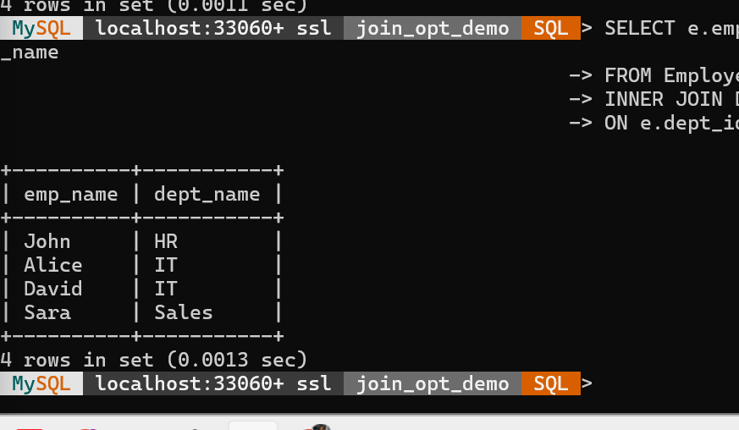

7.Debugging Incorrect Aggregation Results Using GROUP BY in SQL
Step 1: Create Database
CREATE DATABASE groupby_demo;
USE groupby_demo;
Step 2: Create Table
CREATE TABLE Employee(
emp_id INT PRIMARY KEY,
emp_name VARCHAR(50),
department VARCHAR(30),
salary INT
);
Step 3: Insert Records
INSERT INTO Employee VALUES
(101,'John','HR',40000),
(102,'Alice','IT',60000),
(103,'David','IT',70000),
(104,'Sara','HR',50000),
(105,'Kevin','Sales',45000),
(106,'Riya','Sales',55000);
Step 4: Incorrect Query (Wrong GROUP BY)
SELECT department, emp_name, SUM(salary) AS Total_Salary
FROM Employee
GROUP BY emp_name;
Output (Incorrect) 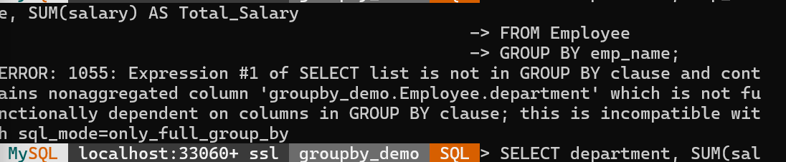
Step 5: Correct Query
SELECT department, SUM(salary) AS Total_Salary
FROM Employee
GROUP BY department;

Output (Correct)
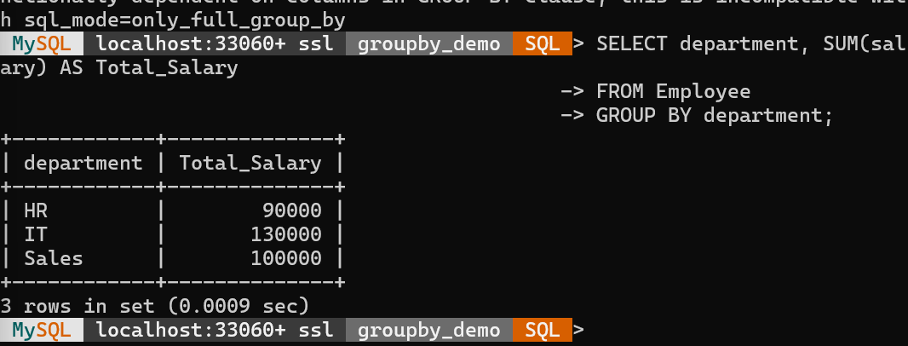

8.Debugging an SQL UPDATE Statement with Missing WHERE Condition
Step 1: Create Database
CREATE DATABASE update_demo;
USE update_demo;
Step 2: Create Table
CREATE TABLE Employee(
emp_id INT PRIMARY KEY,
emp_name VARCHAR(50),
department VARCHAR(30),
salary INT
);
Step 3: Insert Records
INSERT INTO Employee VALUES
(101,'John','HR',40000),
(102,'Alice','IT',60000),
(103,'David','IT',70000),
(104,'Sara','HR',50000);
Step 4: Check Existing Records
SELECT * FROM Employee;

Output
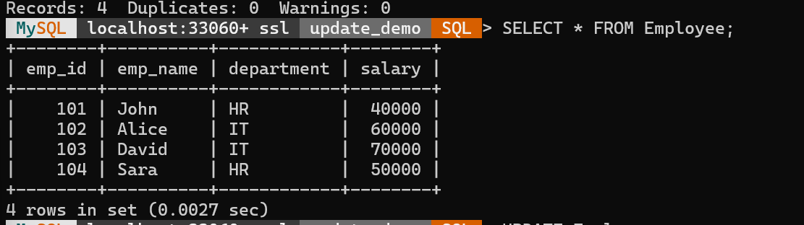
Step 5: Incorrect UPDATE Query (Missing WHERE Condition)
UPDATE Employee
SET salary = 80000;

Output (Incorrect)
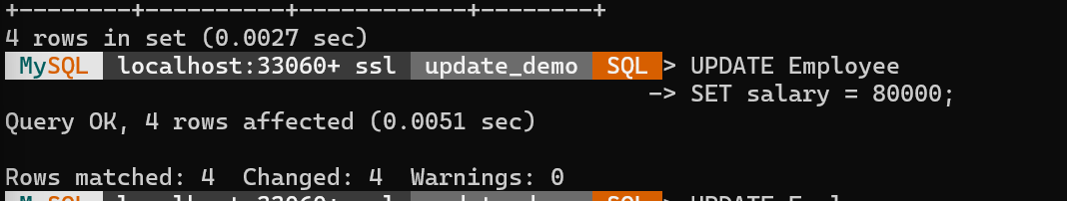

Step 6: Correct UPDATE Query
UPDATE Employee
SET salary = 80000
WHERE emp_id = 102;

Output (Correct)
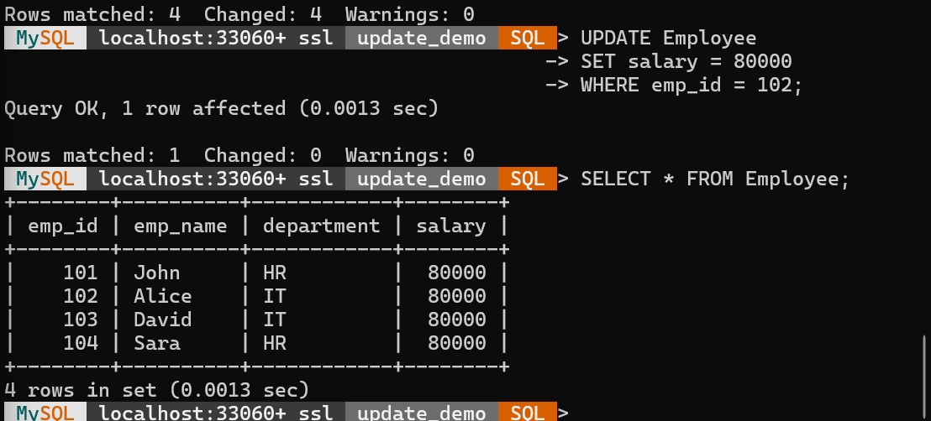

9.Optimizing a Multi-Table SQL Query Using JOINs and Indexes
Step 1: Create Database
CREATE DATABASE optimization_demo;
USE optimization_demo;
Step 2: Create Tables
Department Table
CREATE TABLE Department(
dept_id INT PRIMARY KEY,
dept_name VARCHAR(50)
);
Employee Table
CREATE TABLE Employee(
emp_id INT PRIMARY KEY,
emp_name VARCHAR(50),
dept_id INT,
salary INT,
FOREIGN KEY(dept_id) REFERENCES Department(dept_id)
);
Project Table
CREATE TABLE Project(
project_id INT PRIMARY KEY,
project_name VARCHAR(50),
emp_id INT,
FOREIGN KEY(emp_id) REFERENCES Employee(emp_id)
);
Step 3: Insert Records
Department
INSERT INTO Department VALUES
(1,'HR'),
(2,'IT'),
(3,'Sales');
Employee
INSERT INTO Employee VALUES
(101,'John',1,40000),
(102,'Alice',2,60000),
(103,'David',2,70000),
(104,'Sara',3,50000);
Project
INSERT INTO Project VALUES
(201,'Payroll System',101),
(202,'AI Application',102),
(203,'Cloud Project',103),
(204,'Marketing App',104);
Step 4: Inefficient Query (Using Subqueries)
SELECT emp_name,
(
SELECT dept_name
FROM Department
WHERE Department.dept_id = Employee.dept_id
) AS Department,
(
SELECT project_name
FROM Project
WHERE Project.emp_id = Employee.emp_id
) AS Project
FROM Employee;

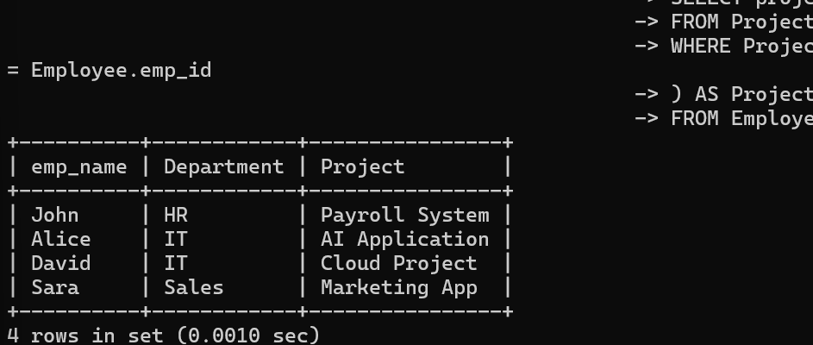
Step 5: Optimized Query Using JOIN
SELECT
e.emp_name,
d.dept_name,
p.project_name
FROM Employee e
JOIN Department d
ON e.dept_id = d.dept_id
JOIN Project p
ON e.emp_id = p.emp_id;
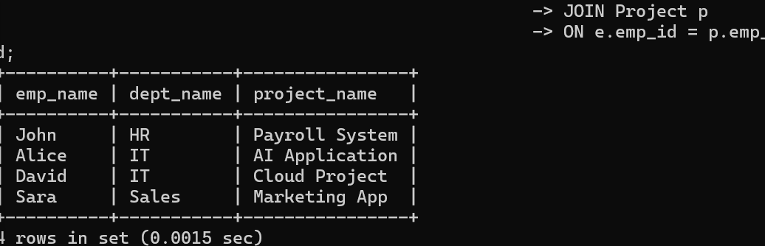

Step 6: Create Indexes
CREATE INDEX idx_employee_dept
ON Employee(dept_id);
CREATE INDEX idx_project_emp
ON Project(emp_id);
Step 7: Execute Optimized Query
SELECT
e.emp_name,
d.dept_name,
p.project_name
FROM Employee e
JOIN Department d
ON e.dept_id = d.dept_id
JOIN Project p
ON e.emp_id = p.emp_id;
OUTPUT
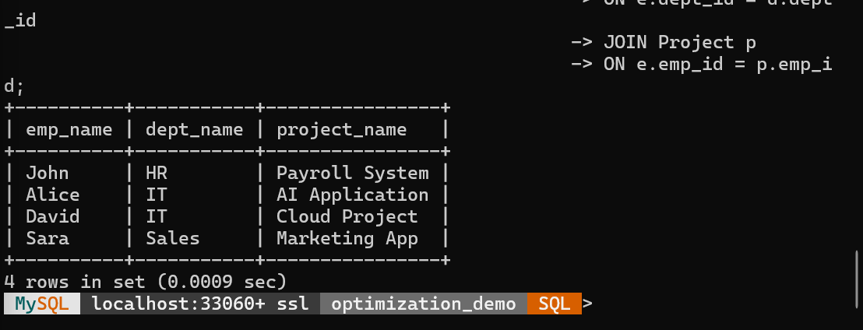

10.Debugging a Relational Calculus Expression with Incorrect Quantifier Usage
Step 1: Create Database
CREATE DATABASE calculus_demo;
USE calculus_demo;
Step 2: Create Tables
Employee Table
CREATE TABLE Employee(
emp_id INT PRIMARY KEY,
emp_name VARCHAR(50),
dept_id INT
);
Department Table
CREATE TABLE Department(
dept_id INT PRIMARY KEY,
dept_name VARCHAR(50)
);
Step 3: Insert Records
Employee Records
INSERT INTO Employee VALUES
(101,'John',1),
(102,'Alice',2),
(103,'David',2);

Department Records
INSERT INTO Department VALUES
(1,'HR'),
(2,'IT'),
(3,'Sales');
Step 4: Incorrect Relational Calculus Expression
Incorrect Expression:
{ e.emp_name | Employee(e) AND
∀d (Department(d) → e.dept_id = d.dept_id)
}
Output (Incorrect)
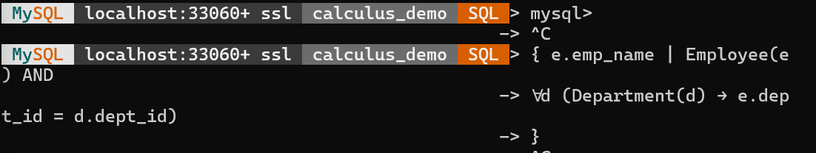
Step 5: Correct Relational Calculus Expression
Correct Expression:
{ e.emp_name | Employee(e) AND
∃d (Department(d) AND e.dept_id = d.dept_id)
}

Output (Correct)
